Google Desktop SolidWorks Plugin Install Instructions:
Note this for those who do not know the command line or how to use regsvr32
- Make sure Google Desktop is already installed.
- Unzip the "GoogleDesktopSolidworksPlugin" folder to your Program Files. If you are using a x64 system, use Program Files (x86).
- Next you need to register the “GoogleDesktopSolidworksPlugin.dll” with windows. For windows 7 (both x86 and x64) , click Start and type CMD. Right click on “cmd.exe” and select “Run as administrator”.

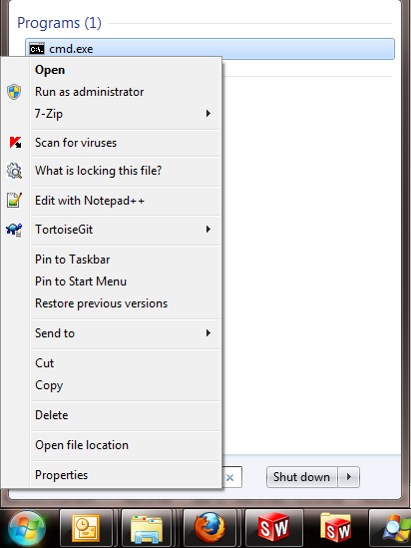

- Type “regsvr32 “. Note the space after regsvr32. Now drag and drop GoogleDesktopSolidworksPlugin.dll onto the black part of CMD.exe window. If you did it right, you should see something like the picture below. Next hit enter. This will register the DLL with windows.
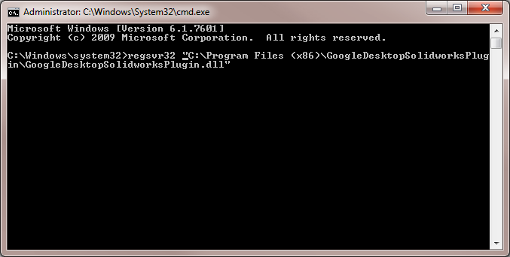
- If you did step 4 right, you will be prompted with the message below. Hit Okay.
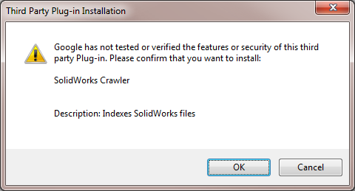

- Next go check Google Desktop Options by right clicking on the Google Desktop Icon in the Notification Area. Like below:
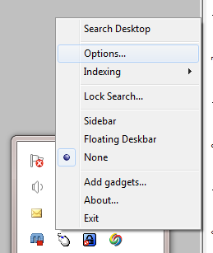

- The options screen looks like the picture below. Under the “Indexing Plug-ins” section, make sure the “SolidWorks Crawler (Indexs SolidWorks files)” is checked. Hit save preferences. If the SolidWorks plugin isn't listed, try repeating from step 4 to step 6.
